

**Belagavi**

**Campus**

**Dr.M.Sheshgiri College of Engineering & Technology**

A Report on the Course Project of

**Engineering Exploration**

**(22ECRP101)**

**Solar Panel Cleaning System**

**(Auto Wipe)**

By

|  |  |  |
| --- | --- | --- |
| Soukhya Madan Nayak | 447 | 02FE22BCS148 |
| Revati Belgali | 423 | 02FE22BCS082 |
| Gagan Muddebihal | 412 | 02FE22BEC028 |
| Darshan Wadralli | 411 | 02FE22BCS033 |

**Under the guidance of**

**PROF. Abhinay Gupta**

**Assistant professor, E&E dept., KLE Tech**

Centre for Engineering Education Research

KLE Technological University, Hubballi

Karnataka.Indai

Academic Year 2022-2023, Even Semester

#### CERTIFICATE

This is to certify that the course project entitled “Solar panel cleaning system” is carried out by the students Soukhya Nayak (447), Revati (423), Darshan (411), Gagan(412) as part of Engineering Exploration Course (22ECRP101), during 1st Semester of B.E program for the academic year 2022-23. The project report fulfils the requirements prescribed by KLE Technological University Dr.M.S.Sheshgiri College of Engineering & Techanology,Belagavi,Karnataka,India

|  |  |
| --- | --- |
| __________________  Guide  PROF. Abhinay Gupta    ________________  Examiner 1: | __________________  Class Teacher  Swati M.  __________________  Examiner 2: |

### DECLARATION

We hereby declare that the project work entitled “Solar panel cleaning system” submitted as a part of Engineering Exploration Course during 2nd semester of academic year 2022-2023, is a record of an original work done by us under the guidance of PROF. Abhinay Gupta. The project work and part of this report is not plagiarized to the best of our knowledge.

Date: 25/07/2023

|  |  |  |  |
| --- | --- | --- | --- |
|  |  |  |  |
| Revati Belagali | Soukhya Nayak | Darshan wadralli | Gagan Muddebihal |
| 423 | 447 | 411 | 412 |

**ACKNOWLEDGEMENT**

I would like to express my sincere thanks to **Prof Abhinay Gupta**, for his/her valuable guidance and support in completing my Course project.

I would like to express my gratitude toward **all my division staffs** as well as the **Prof. S B Kulkarni**  for providing me a great opportunity to complete a  project on solar panel cleaning system. Without their support and suggestions, this project would not have been completed.

I would also like to express my gratitude towards our principal **Dr. S F PATIL** for giving me this great opportunity to do a project on solar panel cleaning system.

**Index**

|  |  |
| --- | --- |
| List of Figures | i |
| List of Tables | ii |
| Abstract | iii |
| 1. Problem Definition | **1** |
| * 1. Need Statement | **1** |
|  |  |
| * 1. Questions asked to client / users for arriving at Objectives, Functions and Constraints | **2** |
| * 1. Objectives | **3** |
| * 1. Constraints | **4** |
| * 1. Functions | **4** |
| 1. Conceptual Design |  |
| * 1. Establishing Functions | **5** |
| * 1. Functions Tree | **6** |
| * 1. Morphological Chart | **6** |
| * 1. Generated Concepts | **7** |
| 1. Conceptual Evaluation and Product Architecture |  |
| * 1. Pugh Chart | **8** |
| * 1. Justification for the Scores | **9** |
| * 1. Selected Design | **10** |
| * 1. Product Architecture      1. Function Clustering | **10** |
| * + 1. Interaction between subsystems | **11** |
| 1. Implementation    1. Sprint 1 Implementation       1. 3D model of the sprint 1 | **12** |
| * 1. Sprint 2 Implementation |  |
| * + 1. Circuit diagram of the sprint 2 | **14** |
| * 1. Sprint 1 Implementation |  |
| * + 1. Physical implementation image of the sprint 3 | **15** |
| * 1. Motor and Resource Specification | **16** |
| 1. Statement of Expenditure | **19** |
| 1. Limitations of Present work and Future Scope | **20** |
| 1. References |  |

**List of Figure**

|  |  |  |
| --- | --- | --- |
| **Fig No** | **Name of the Figure** | **Page No** |
| 1 | Function Tree | **6** |
| 2 | Generated concepts | **7** |
| 3 | Selected concepts | **10** |
| 4 | Function Clustering | **10** |
| 5 | Circuit diagram | **16** |

**List of Table**

|  |  |  |
| --- | --- | --- |
| **Table No** | **Name of the Table** | **Page No** |
| 1 | Morphological chart | **6** |
| 2 | Pugh chart | **8** |
| 3 | Interaction table | **11** |
|  |  |  |

**Abstract**

Solar panel will get dirt, as it is exposed to surrounding, specially during monsoon time, algae will grow on the top of the solar panel. This makes a layer and unable to trap the sun light. Therefore, it is needed to clean the panel. In large scale industries applications it is very difficult to clean the solar panel manually. In domestic applications also due to the busy schedule of the people and lack of labourers it is very difficult to clean the solar panel. Hence we implemented a an automatic solar panel cleaning system,which reduces human efforts and cleans automatically and fast.

**1. Problem Definition**

**1.1. Need Statement**

Tata Solar Power company requires automatic solar panel cleaning system which is automatic, user-friendly,which does dry cleaning and do not harm the solar panel and skratch resistant.

**1.3. Questions asked to client / users for arriving at Objectives, Functions and Constraints**

|  |  |  |  |  |  |
| --- | --- | --- | --- | --- | --- |
| Sl. No. | Questions | Answers | O | C | F |
| 1 | What is the dimensions of solar panel? | 1ft*1ft*1ft |  | ☑ |  |
| 2 | What kind of cleaning do you want? | Automatic cleaning |  |  | ☑ |
| 3 | What type of cleaning material should use? | Soft material | ☑ |  |  |
| 4 | What should be the cost of solar panel cleaning system? | Less than 4000 | ☑ |  |  |
| 5 | How should be the cleaning machine? | Yes,it should be portable | ☑ |  |  |
| 6 | What should be the operational time of cleaning material? | 3 minutes |  | ☑ |  |
| 7 | What kind of power supply do you want? | Battery or current supply | ☑ |  |  |
| 8 | Should the solar panels need regular cleaning? | Twice a week |  |  | ☑ |
| 9 | What type of cleaning agent must be used? | Dry cleaning agents | ☑ |  |  |
| 10 | How frequently do you want to clean in a week? | Atleast 2 times a week | ☑ |  |  |
| 11 | What other features are expected? | Indication |  |  | ☑ |
| 12 | What should be the weight of solar panel? | It must be within 2kg |  | ☑ |  |

**1.4. Objectives**

|  |  |
| --- | --- |
| Sl. No | Objectives |
| 1 | Machine should be automatic |
| 2 | Dry cleaning |
| 3 | Machine should be user friendly |
| 4 | Mmachine should clean the panel |
| 5 | Machine should not scratch the panel |
| 6 | Machine should clean the panel smoothly |

**Problem definition 1.1**

Tata Solar Power company requires automatic solar panel cleaning system which is automatic, user-friendly,which does dry cleaning and do not harm the solar panel and scratch resistant.

**1.5. Constraints**

|  |  |
| --- | --- |
| **Sl. No** | **Constraints** |
| 1 | Machine should be 1ft*1ft*1ft |
| 2 | Cost of the machine should be less than 4000 |
| 3 | Machine should clean the panel within max of 3 minutes |
| 4 | Machine should weight within 2kg |

**Problem definition 1.2**

Tata Solar Power company requires automatic solar panel cleaning system which is automatic, user-friendly, which does dry cleaning and do not harm the solar panel and scratch resistant. Solar panel cleaning machine must be 1ft *1ft *1ft and the cost of the machine should be less than 4000 and it should clean within 3 minutes.

**1.6. Functions**

|  |  |
| --- | --- |
| **Sl. No** | **Functions** |
| 1 | Indication when the the machine starts |
| 2 | Control the movement of cleaner |
| 3 | Indicating once the cleaning is done |
| 4 | Control the cleaner through remote |
| 5 | Indication when there is dirt on the panel |

**Problem definition 1.3**

Tata Solar Power company requires automatic solar panel cleaning system which is automatic, user-friendly, which does dry cleaning and do not harm the solar panel and scratch resistant. Solar panel cleaning system should be 1ft *1ft *1ft and the cost of the machine should be less than 4000 and it should clean within 3 minutes. Machine should give indication once cleaning begins and also when cleaning is complete .

**2. Conceptual Design**

**2.1. Establishing Functions**

|  |  |  |
| --- | --- | --- |
| **Sl. No** | **Functions from user perspective** | **Functions from the designer perspective** |
| 1 | Controlling the cleaner through remote | Indication when the machine starts |
| 2 | Use soft material for cleaning | Dry cleaning |
| 3 | It should be cost effective | Cleaning must be done within 5 minutes |
| 4 | Controlling moment of cleaner | Indicating once cleaning is done |
| 5 | Indicating off and on function | Cleaner should remove all dirt from panel |
| 6 | Indicating the time taken to clean the panel | Switching on and off |

**2.2. Functions Tree (fig.1)**

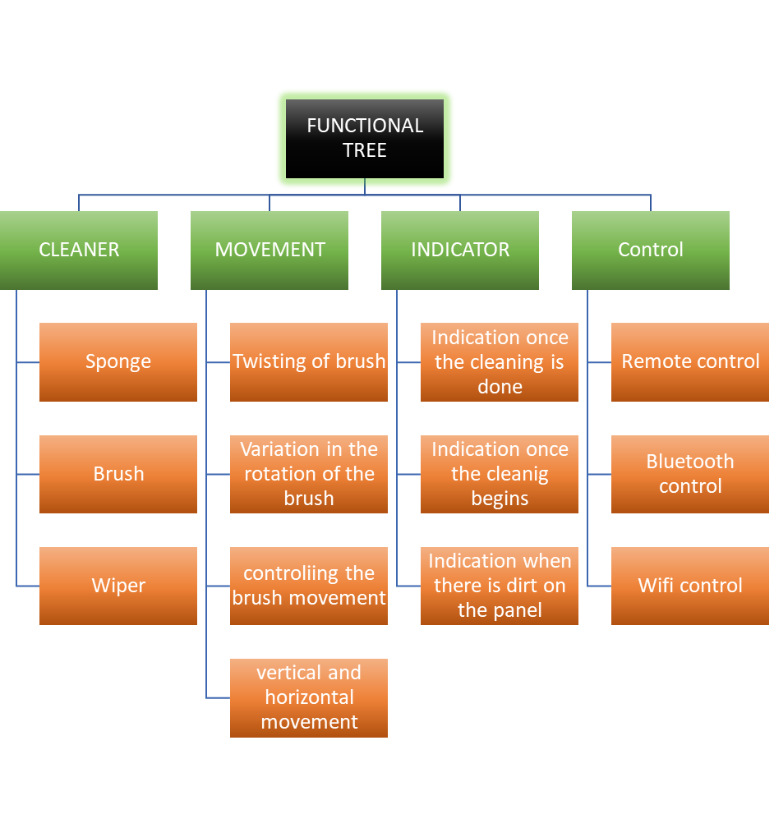

**2.3. Morphological Chart (Table 1)**

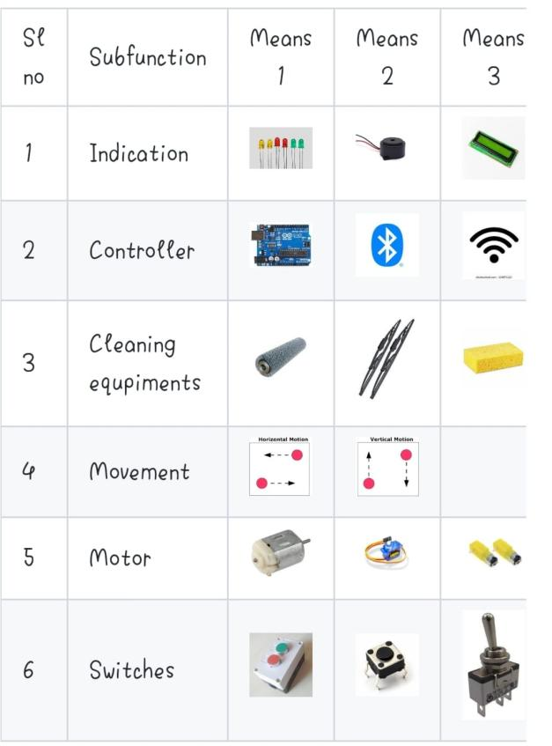

**2.4. Generated Concepts(Fig 2)**

|  |  |
| --- | --- |
| **Concept 1**  WhatsApp Image 2023-05-21 at 22 30 17 | **Concept 3**  WhatsApp Image 2023-05-21 at 22 29 05 |
| **Concept 2**  WhatsApp Image 2023-07-16 at 15 39 51 | **Concept 4**  image |

**3. Conceptual Evaluation and Product Architecture**

**3.1. Pugh Chart ( Table 2)**

For final concept is selection we have used pugh chart as shown in the table.

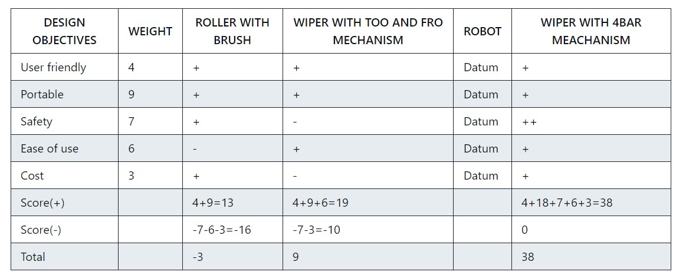

**3.2. Justification for the Score(Table 3)**

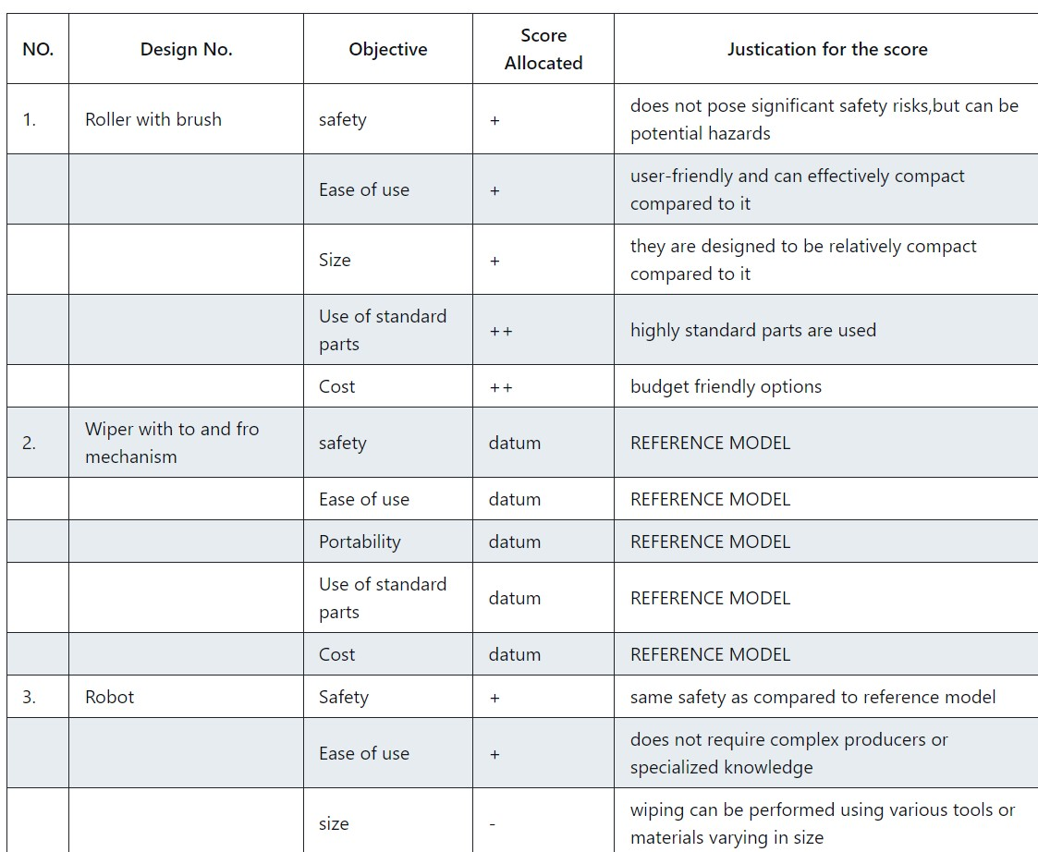

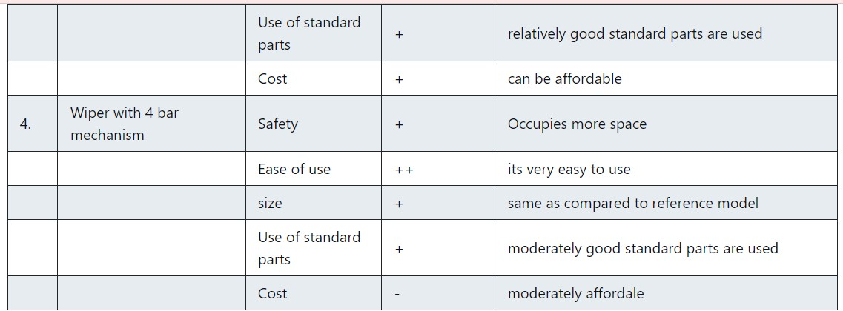

**3.3 Selected Design (Fig 3)**

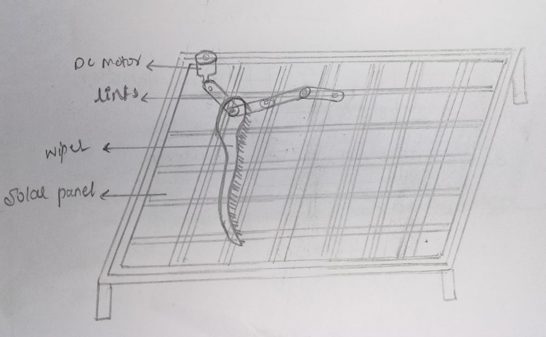

**3.4 Product Architecture**

**3.4.1 Function Clustering (Fig 4)**

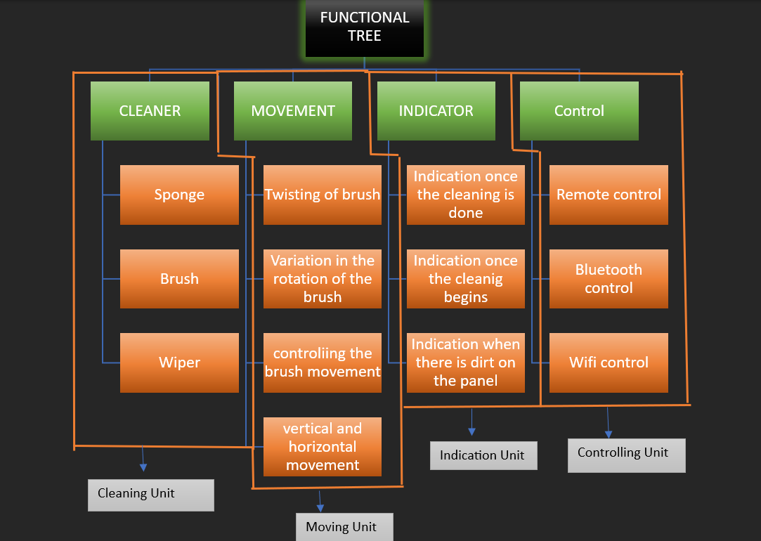

**3.4.2 Interaction between subsystems (Table 3)**

|  |  |  |  |
| --- | --- | --- | --- |
|  | Cleaning unit | **Moving unit** | **Indication unit** |
| Sub System 1 | Spatial | yes | no |
| Data | No | yes |
| Materail | Yes | yes |

|  |  |  |  |
| --- | --- | --- | --- |
|  | Moving unit | **Cleaning unit** | **Indication unit** |
| Sub System 2 | Spatial | Yes | no |
| Data | yes | Yes |
| Materail | yes | No |

|  |  |  |  |
| --- | --- | --- | --- |
|  | Indicating unit | **Cleaning unit** | **Moving unit** |
| Sub System 3 | Spatial | No | No |
| Data | yes | yes |
| Materail | No | No |

**4.** **Implementation**

**4.1.** **Sprint 1 Implementation**

**4.1.1. 3D model of the sprint 1 subsystem**

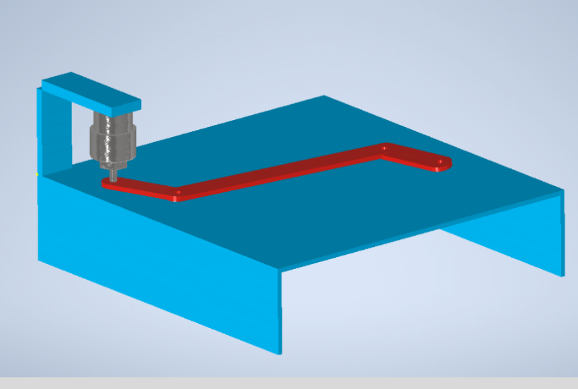

**4.2.** **Sprint 2 Implementation**

**4.2.1. 3D model of the sprint 2**

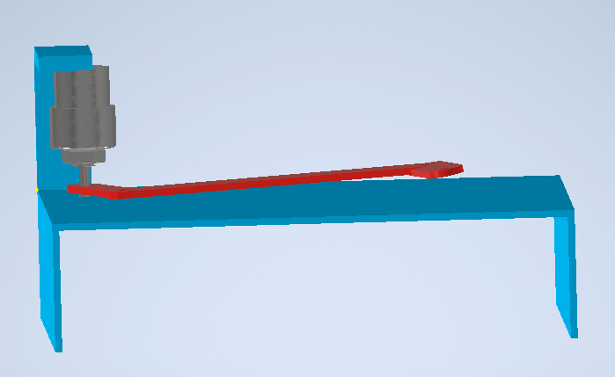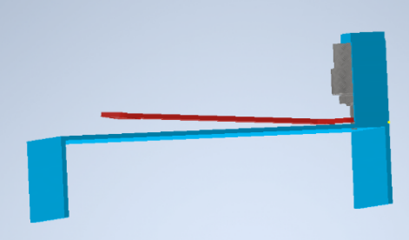

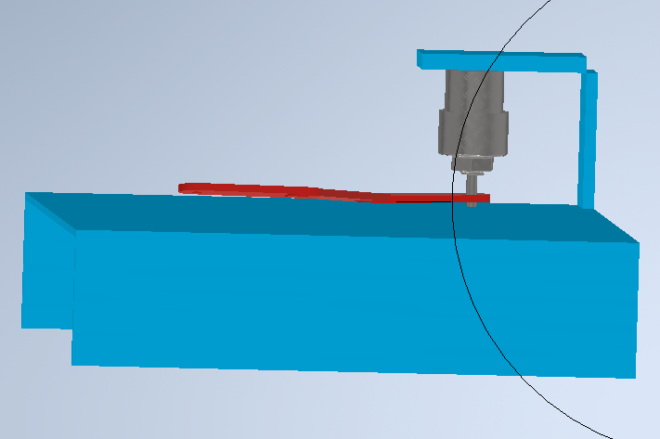

**4.2.3. Circuit diagram of the sprint 2 (Fig 5)**

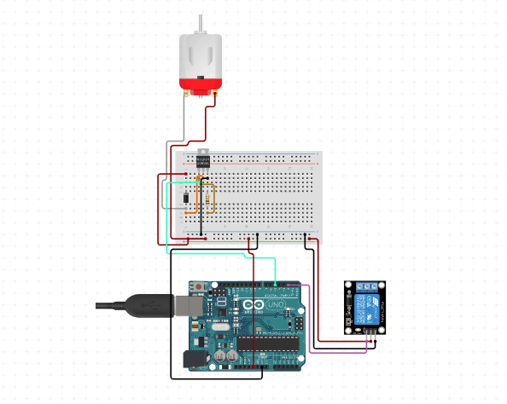

4.2.4 Flow chart of the sprint 2

**4.3.** **Sprint 3 Implementation**

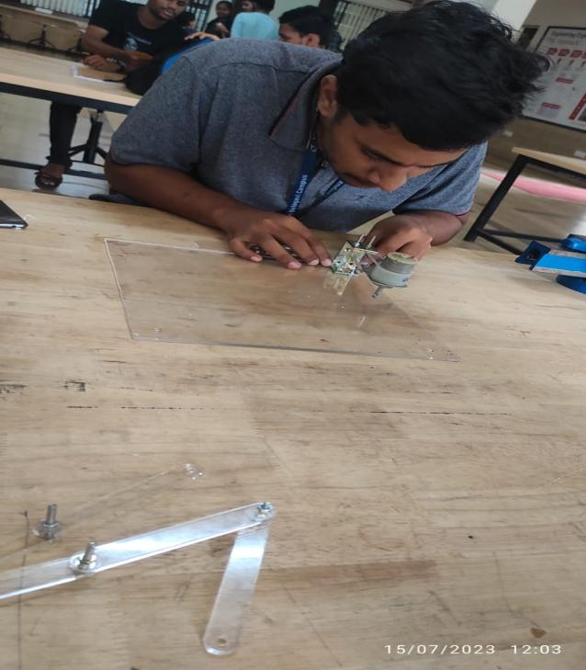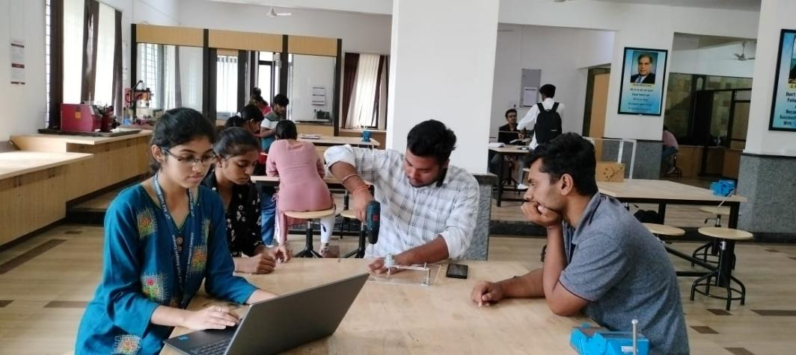

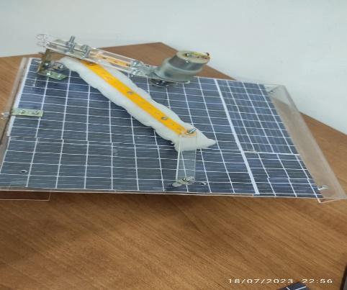

# 4.3 .4 Flow chart of sprint 3

**4.2 Motor RPM Caalculation**

**DENSITY**

**Acrylic Steel**

**1.18g/cm^3 7.85g/cm^3**

**VOLUME**

**link-1**

**10cm * 1.5cm*0.4cm**

**6cm^3**

**link-2**

**1.5cm * 21cm*0.2cm**

**6.3cm^3**

**link-3**

**1.5cm * 10cm*0.2cm**

**3cm^3**

**sponge**

**3cm 1.5cm23cm**

**103.5cm^3**

**MASS**

**link-1**

**7.08g**

**link-2**

**49.45g**

**link-3**

**23.55g**

**sponge**

**105.57g**

**TOTAL MASS**

**70.8g + 49.45g + 23.55g + 105.47g = 186.37g**

**0.18367kg**

**FORCE**

**Force= mass * g**

**Force = 0.1836kg * 9.8 m/s^2**

**1.826N**

**TORQUE**

**torque = force * distance * fos**

**torque = 1.826 * 1.34 * 1.5**

**3.5 kg cm**

**RPM OF MOTOR IS 60 RPM**

**5**. **Statement of Expenditure**

|  |  |  |  |
| --- | --- | --- | --- |
| Sl. No | Item with description | Quantity | Price in Rs. |
| 1 | Motor | 1 | 113 |
| 2 | Relay | 1 | 100 |
| 3 | Adapter | 1 | 300 |
| 4 | Data cable | 1 | 150 |
| 5 | Arduino | 1 | 285 |
| 6 | Sponge | 1 | 10 |
| 7 | Wires | 25 | 100 |
| 8 | Links | 4 | 150 |
| Total | | | 1208 |
|  | | |  |

.

**6. Limitations of Present work**

There are some of the limitations for our model which have to look into it and work for

1. Unable to clean the small portion of area
2. Unable to clean the sponge
3. Need of pressure while cleaning

**Future Scope**

By using automatic solar panel cleaning system, human work can be reduced, the machine can be made still larger so that the work becomes easy.

**References:**

1. <https://www.circuito.io/>
2. <http://www.jpsolarenergy.com/solar-cleaning-system.php>
3. <https://www.autodesk.com/education/home>